UNITED STATES
SECURITIES AND EXCHANGE COMMISSION
Washington, D.C. 20549

FORM 8-K

Current Report
Pursuant to Section 13 or 15(d)
of the Securities Exchange Act of 1934
Date of Report (Date of earliest event reported) July 28, 2026


LANDSTAR SYSTEM, INC.
(Exact name of registrant as specified in its charter)

Delaware |  | 021238 |  | 06-1313069
(State or other jurisdiction  of incorporation) |  | (Commission  File Number) |  | (I.R.S. Employer  Identification No.)

13410 Sutton Park Drive South, Jacksonville, Florida |  | 32224
(Address of principal executive offices) |  | (Zip Code)
(904) 398-9400
(Registrant’s telephone number, including area code)
N/A
(Former name or former address, if changed since last report)

Check the appropriate box below if the Form 8-K filing is intended to simultaneously satisfy the filing obligation of the registrant under any of the following provisions:

☐ | Written communications pursuant to Rule 425 under the Securities Act (17 CFR 230.425)

☐ | Soliciting material pursuant to Rule 14a-12 under the Exchange Act (17 CFR 240.14a-12)

☐ | Pre-commencement communications pursuant to Rule 14d-2(b) under the Exchange Act (17 CFR 240.14d-2(b))

☐ | Pre-commencement communications pursuant to Rule 13e-4(c) under the Exchange Act (17 CFR 240.13e-4(c))
Securities registered pursuant to Section 12(b) of the Act:

Title of each class |  | Trading  Symbol(s) |  | Name of each exchange  on which registered
Common Stock |  | LSTR |  | NASDAQ
Indicate by check mark whether the registrant is an emerging growth company as defined in Rule 405 of the Securities Act of 1933 (§230.405 of this chapter) or Rule 12b-2 of the Securities Exchange Act of 1934 (§240.12b-2 of this chapter).
Emerging growth company ☐
If an emerging growth company, indicate by check mark if the registrant has elected not to use the extended transition period for complying with any new or revised financial accounting standards provided pursuant to Section 13(a) of the Exchange Act. ☐

Item 2.02 | Results of Operations and Financial Condition
On July 28, 2026, Landstar System, Inc. (“Landstar” or the “Company”) issued a press release announcing results for the second quarter of fiscal 2026. A copy of the press release is attached hereto as Exhibit 99.1.
The information contained in Item 7.01 concerning the presentation to Landstar investors is hereby incorporated into this Item 2.02 by reference.
The information furnished under Item 2.02 of this Current Report on Form 8-K, including Exhibit 99.1 hereto, shall not be deemed “filed” for purposes of Section 18 of the Securities Exchange Act of 1934, nor shall it be deemed incorporated by reference in any filing under the Securities Act of 1933.

Item 7.01 | Regulation FD Disclosure
A slide presentation, dated July 28, 2026, is attached hereto as Exhibit 99.2 and is incorporated herein by reference. The slide presentation provides information that may be referred to by the Company on its conference call with investors scheduled to occur on July 28, 2026 in connection with the Company’s release of results for the second quarter of fiscal 2026.
The information furnished under Item 7.01 of this Current Report on Form 8-K, including Exhibit 99.2 hereto, shall not be deemed “filed” for purposes of Section 18 of the Securities Exchange Act of 1934, nor shall it be deemed incorporated by reference in any filing under the Securities Act of 1933.

Item 9.01 | Financial Statements and Exhibits
Exhibits

99.1 | Press Release, dated July 28, 2026, of Landstar System, Inc.

99.2 | Slide Presentation, dated July 28, 2026, of Landstar System, Inc.

104 | Inline XBRL for the cover page of this Current Report on Form 8-K

SIGNATURES
Pursuant to the requirements of the Securities Exchange Act of 1934, the Registrant has duly caused this report to be signed on its behalf by the undersigned hereunto duly authorized.

 |  |  |  | LANDSTAR SYSTEM, INC.
Date: July 28, 2026 |  |  |  | By: |  | /s/ James P. Todd
 |  |  |  | Name: |  | James P. Todd
 |  |  |  | Title: |  | Vice President, Chief Financial Officer and Assistant Secretary
Exhibit 99.1

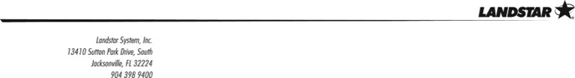

For Immediate Release |  | July 28, 2026
LANDSTAR SYSTEM REPORTS SECOND QUARTER
REVENUE OF $1.432B AND EARNINGS PER SHARE OF $1.44
Jacksonville, FL – Landstar System, Inc. (NASDAQ: LSTR) (“Landstar” or the “Company”) today reported its financial results for the 2026 second quarter. The Company reported total revenue of $1.432 billion in the 2026 second quarter, an increase of 18% as compared to revenue of $1.211 billion in the 2025 second quarter, and basic and diluted earnings per share (“EPS”) of $1.44 in the 2026 second quarter, an increase of 20% as compared to EPS of $1.20 per share in the 2025 second quarter. The Company also reported a 21% increase in gross profit and a 17% increase in variable contribution (defined as revenue less the cost of purchased transportation and commissions to agents) in the 2026 second quarter, as compared in each case to the 2025 second quarter.
“The Landstar team of independent business owners and employees truly shined in a rapidly improving freight transportation backdrop. I was pleased that our network generated both truck volumes and truck revenue per load that outpaced normal seasonal patterns, with variable contribution increasing approximately 17% year-over-year,” said Landstar President and Chief Executive Officer Frank Lonegro. “I was delighted to see our net 68 BCO truck additions during the second quarter, the strongest quarterly improvement since the first quarter of 2022. Although the Company experienced a lower DOT accident frequency during the 2026 first half, increased insurance and claims expense, primarily attributable to unfavorable development of prior years’ claims, had an adverse impact on our second quarter results. The claim environment for freight transportation providers remains challenging, especially with the U.S. Supreme Court’s recent Montgomery decision relating to potential broker liability.”

LANDSTAR SYSTEM/2

 |  | 2Q 2026 |  |  |  | 2Q 2025 |  |  |  | Change ($) |  |  |  | Change (%)
Revenue |  | $ | 1,432,264 |  |  | $ | 1,211,383 |  |  | $ | 220,881 |  |  |  | 18.2 | %
Gross profit |  | $ | 132,337 |  |  | $ | 109,261 |  |  | $ | 23,076 |  |  |  | 21.1 | %
Variable contribution |  | $ | 199,429 |  |  | $ | 170,450 |  |  | $ | 28,979 |  |  |  | 17.0 | %
Operating income |  | $ | 66,228 |  |  | $ | 56,280 |  |  | $ | 9,948 |  |  |  | 17.7 | %
Basic and diluted earnings per share (“EPS”) |  | $ | 1.44 |  |  | $ | 1.20 |  |  | $ | 0.24 |  |  |  | 20.0 | %

(1) | Dollars above in thousands, except per share amounts.
(2) | Please refer to the Consolidated Statements of Income and the Reconciliation of Gross Profit to Variable Contribution included below.
Landstar also announced today that its Board of Directors declared a quarterly dividend of $0.44 per share payable on September 9, 2026, to stockholders of record as of the close of business on August 18, 2026. This quarterly dividend includes a 10% increase over the amount of the Company’s regular quarterly dividend declared following each of the prior five quarters. It is currently the intention of the Board to continue to pay dividends on a quarterly basis going forward. Landstar continues to return capital to stockholders through the Company’s stock purchase program and dividends. While Landstar did not purchase shares in the second quarter, during the 2026 first half, Landstar purchased 150,923 shares of its common stock at an aggregate cost of $22.6 million. The Company is currently authorized to purchase up to an additional 1,115,195 shares of the Company’s common stock under its longstanding share purchase program.
During the 2026 second quarter, truck revenue was $1,334 million, or 19% higher, as compared to the 2025 second quarter truck revenue of $1,118 million. Truck revenue per load increased approximately 17% in the 2026 second quarter compared to the 2025 second quarter, and the number of loads hauled via truck increased approximately 2% compared to the 2025 second quarter.
Truck transportation revenue hauled by independent business capacity owners (“BCOs”) and truck brokerage carriers in the 2026 second quarter was 93% of revenue, compared to 92% of revenue in the 2025 second quarter. Truckload transportation revenue hauled via van equipment in the 2026 second quarter was $718 million, compared to $591 million in the 2025 second quarter. Truckload transportation revenue hauled via unsided/platform equipment in the 2026 second quarter was $492 million, compared to $401 million in the

LANDSTAR SYSTEM/3

2025 second quarter. Revenue from other truck transportation, which is largely related to power-only services, in the 2026 second quarter was $99 million, compared to $101 million in the 2025 second quarter. Revenue hauled by rail, air and ocean cargo carriers was $78 million, or 5% of revenue, in the 2026 second quarter, compared to $73 million, or 6% of revenue, in the 2025 second quarter.
Gross profit in the 2026 second quarter was $132 million, as compared to $109 million in the 2025 second quarter. Variable contribution in the 2026 second quarter was $199 million, compared to $170 million in the 2025 second quarter. Reconciliations of gross profit to variable contribution and gross profit margin to variable contribution margin for the 2026 and 2025 second quarters and year-to-date periods are provided in the Company’s accompanying financial disclosures.
The Company’s balance sheet continues to be very strong, with cash and short-term investments of approximately $348 million as of June 27, 2026. Trailing twelve-month return on average shareholders’ equity was 16%. Return on invested capital, representing net income divided by the sum of average equity plus average debt, was 14%.
Landstar will provide a live webcast of its quarterly earnings conference call this afternoon at 4:30 p.m. ET. To access the webcast, visit www.investor.landstar.com; click on “Webcasts,” then click on “Landstar’s Second Quarter 2026 Earnings Release Conference Call.” A slide presentation to accompany the webcast presentation is also available on Landstar’s investor relations website at https://investor.landstar.com/.
Contact:
Jim Todd
Chief Financial Officer
904-398-9400

LANDSTAR SYSTEM/4

About Landstar:
Landstar System, Inc., is a technology-enabled, asset-light provider of freight transportation and logistics solutions focused on safety, security and service to a broad range of customers utilizing a network of agents, third-party capacity providers and employees. Landstar transportation services companies are certified to ISO 9001:2015 quality management system standards and RC14001:2015 environmental, health, safety and security management system standards. Landstar System, Inc. is headquartered in Jacksonville, Florida. Its common stock trades on The NASDAQ Stock Market® under the symbol LSTR.
Non-GAAP Financial Measures:
In this earnings release and accompanying financial disclosures, the Company provides the following information that may be deemed non-GAAP financial measures: variable contribution and variable contribution margin. The Company believes variable contribution and variable contribution margin are useful measures of the variable costs that we incur at a shipment-by-shipment level attributable to our transportation network of third-party capacity providers and independent agents in order to provide services to our customers. The Company also believes that it is appropriate to present each of the financial measures that may be deemed a non-GAAP financial measure, as referred to above, for the following reasons: (1) disclosure of these matters will allow investors to better understand the underlying trends in the Company’s financial condition and results of operations; (2) this information will facilitate comparisons by investors of the Company’s results as compared to the results of peer companies; and (3) management considers this financial information in its decision making.
Forward Looking Statements Disclaimer:
The following is a “safe harbor” statement under the Private Securities Litigation Reform Act of 1995. Statements contained in this press release that are not based on historical facts are “forward-looking statements.” This press release contains forward-looking statements, such as statements which relate to Landstar’s business objectives, plans, strategies and expectations. Terms such as “anticipates,” “believes,” “estimates,” “intention,” “expects,” “plans,” “predicts,” “may,” “should,” “could,” “would,” “will,” the negative thereof and similar expressions are intended to identify forward-looking statements. Such statements are by nature subject to uncertainties and risks, including but not limited to: decreased demand for transportation services; U.S. trade relationships and potential or imposed tariffs; an increase in the frequency or severity of accidents or

LANDSTAR SYSTEM/5

other claims; unfavorable development of existing accident claims; dependence on third party insurance companies; dependence on independent commission sales agents; dependence on third party capacity providers; the impact of the Russian conflict with Ukraine on the operations of certain independent commission sales agents, including the Company’s second largest such agent by revenue in the 2025 fiscal year; substantial industry competition; disruptions or failures in the Company’s computer systems; cyber and other information security incidents; dependence on key vendors; potential changes in taxes; status of independent contractors; regulatory and legislative changes; regulations focused on diesel emissions and other air quality matters; regulations requiring the purchase and use of zero-emission vehicles; intellectual property; acquisitions and investments; and other operational, financial or legal risks or uncertainties detailed in Landstar’s Form 10-K for the 2025 fiscal year, described in Part I, Item 1A Risk Factors, and in other SEC filings from time to time. These risks and uncertainties could cause actual results or events to differ materially from historical results or those anticipated. Investors should not place undue reliance on such forward-looking statements, and the Company undertakes no obligation to publicly update or revise any forward-looking statements.

LANDSTAR SYSTEM/6

Landstar System, Inc. and Subsidiary
Consolidated Statements of Income
(Dollars in thousands, except per share amounts)
(Unaudited)

 |  | Twenty-Six Weeks Ended |  |  |  |  |  |  |  | Thirteen Weeks Ended
 |  | June 27,  2026 |  |  |  | June 28,  2025 |  |  |  | June 27,  2026 |  |  |  | June 28,  2025
Revenue |  | $ | 2,603,555 |  |  | $ | 2,363,885 |  |  | $ | 1,432,264 |  |  | $ | 1,211,383
Investment income |  |  | 5,679 |  |  |  | 7,327 |  |  |  | 2,705 |  |  |  | 3,729
Costs and expenses:
Purchased transportation |  |  | 2,030,397 |  |  |  | 1,839,289 |  |  |  | 1,123,400 |  |  |  | 941,411
Commissions to agents |  |  | 201,578 |  |  |  | 192,836 |  |  |  | 109,435 |  |  |  | 99,522
Other operating costs, net of gains on asset sales/dispositions |  |  | 32,745 |  |  |  | 31,424 |  |  |  | 17,945 |  |  |  | 19,595
Insurance and claims |  |  | 74,923 |  |  |  | 70,301 |  |  |  | 39,359 |  |  |  | 30,449
Selling, general and administrative |  |  | 129,158 |  |  |  | 117,288 |  |  |  | 68,193 |  |  |  | 55,706
Depreciation and amortization |  |  | 20,969 |  |  |  | 24,375 |  |  |  | 10,409 |  |  |  | 12,149
Total costs and expenses |  |  | 2,489,770 |  |  |  | 2,275,513 |  |  |  | 1,368,741 |  |  |  | 1,158,832
Operating income |  |  | 119,464 |  |  |  | 95,699 |  |  |  | 66,228 |  |  |  | 56,280
Interest and debt expense |  |  | 1,330 |  |  |  | 539 |  |  |  | 812 |  |  |  | 698
Income before income taxes |  |  | 118,134 |  |  |  | 95,160 |  |  |  | 65,416 |  |  |  | 55,582
Income taxes |  |  | 29,743 |  |  |  | 23,461 |  |  |  | 16,465 |  |  |  | 13,689
Net income |  | $ | 88,391 |  |  | $ | 71,699 |  |  | $ | 48,951 |  |  | $ | 41,893
Basic and diluted earnings per share |  | $ | 2.60 |  |  | $ | 2.05 |  |  | $ | 1.44 |  |  | $ | 1.20
Average basic and diluted shares outstanding |  |  | 33,979,000 |  |  |  | 35,037,000 |  |  |  | 33,935,000 |  |  |  | 34,870,000
Dividends per common share |  | $ | 0.80 |  |  | $ | 0.76 |  |  | $ | 0.40 |  |  | $ | 0.40

LANDSTAR SYSTEM/7

Landstar System, Inc. and Subsidiary
Consolidated Balance Sheets
(Dollars in thousands, except per share amounts)
(Unaudited)

 |  | June 27,  2026 |  |  |  | December 27,  2025
ASSETS
Current assets:
Cash and cash equivalents |  | $ | 294,350 |  |  | $ | 396,694
Short-term investments |  |  | 53,352 |  |  |  | 55,531
Trade accounts receivable, less allowance of $9,135 and $12,490 |  |  | 866,879 |  |  |  | 670,137
Other receivables, including advances to independent contractors, less allowance of $14,727 and $18,759 |  |  | 47,306 |  |  |  | 52,784
Assets held for sale |  |  | — |  |  |  | 12,231
Other current assets |  |  | 59,159 |  |  |  | 28,949
Total current assets |  |  | 1,321,046 |  |  |  | 1,216,326
Operating property, less accumulated depreciation and amortization of $488,271 and $473,642 |  |  | 252,963 |  |  |  | 261,322
Goodwill |  |  | 34,005 |  |  |  | 34,005
Other assets |  |  | 134,521 |  |  |  | 124,282
Total assets |  | $ | 1,742,535 |  |  | $ | 1,635,935
LIABILITIES AND SHAREHOLDERS’ EQUITY
Current liabilities:
Cash overdraft |  | $ | 71,849 |  |  | $ | 56,654
Accounts payable |  |  | 468,780 |  |  |  | 369,567
Current maturities of long-term debt |  |  | 24,686 |  |  |  | 28,342
Insurance claims |  |  | 59,020 |  |  |  | 87,343
Dividends payable |  |  | — |  |  |  | 68,117
Liabilities held for sale |  |  | — |  |  |  | 6,961
Other current liabilities |  |  | 99,588 |  |  |  | 78,856
Total current liabilities |  |  | 723,923 |  |  |  | 695,840
Long-term debt, excluding current maturities |  |  | 42,088 |  |  |  | 48,480
Insurance claims |  |  | 98,686 |  |  |  | 62,706
Deferred income taxes and other non-current liabilities |  |  | 41,108 |  |  |  | 33,244
Shareholders’ equity:
Common stock, $0.01 par value, authorized 160,000,000 shares, issued 68,631,174 and 68,590,708 |  |  | 686 |  |  |  | 686
Additional paid-in capital |  |  | 266,673 |  |  |  | 261,256
Retained earnings |  |  | 2,913,890 |  |  |  | 2,852,680
Cost of 34,694,249 and 34,531,982 shares of common stock in treasury |  |  | (2,336,862 | ) |  |  | (2,313,245 | )
Accumulated other comprehensive loss |  |  | (7,657 | ) |  |  | (5,712 | )
Total shareholders’ equity |  |  | 836,730 |  |  |  | 795,665
Total liabilities and shareholders’ equity |  | $ | 1,742,535 |  |  | $ | 1,635,935

LANDSTAR SYSTEM/8

Landstar System, Inc. and Subsidiary
Supplemental Information
(Unaudited)

 |  | Twenty-Six Weeks Ended |  |  |  |  |  |  |  | Thirteen Weeks Ended
 |  | June 27,  2026 |  |  |  | June 28,  2025 |  |  |  | June 27,  2026 |  |  |  | June 28,  2025
Revenue generated through (in thousands):
Truck transportation
Truckload:
Van equipment |  | $ | 1,320,919 |  |  | $ | 1,186,071 |  |  | $ | 717,513 |  |  | $ | 591,276
Unsided/platform equipment |  |  | 860,737 |  |  |  | 741,270 |  |  |  | 492,168 |  |  |  | 400,862
Less-than-truckload |  |  | 48,912 |  |  |  | 47,749 |  |  |  | 25,124 |  |  |  | 25,313
Other truck transportation (1) |  |  | 185,591 |  |  |  | 192,766 |  |  |  | 99,073 |  |  |  | 100,687
Total truck transportation |  |  | 2,416,159 |  |  |  | 2,167,856 |  |  |  | 1,333,878 |  |  |  | 1,118,138
Rail intermodal |  |  | 47,075 |  |  |  | 39,515 |  |  |  | 27,761 |  |  |  | 22,028
Ocean and air cargo carriers |  |  | 97,713 |  |  |  | 116,426 |  |  |  | 49,744 |  |  |  | 50,789
Other (2) |  |  | 42,608 |  |  |  | 40,088 |  |  |  | 20,881 |  |  |  | 20,428
 |  | $ | 2,603,555 |  |  | $ | 2,363,885 |  |  | $ | 1,432,264 |  |  | $ | 1,211,383
Revenue on loads hauled via BCO Independent Contractors (3) included in total truck transportation |  | $ | 1,038,421 |  |  | $ | 888,489 |  |  | $ | 563,073 |  |  | $ | 461,432
Number of loads:
Truck transportation
Truckload:
Van equipment |  |  | 575,472 |  |  |  | 572,154 |  |  |  | 297,761 |  |  |  | 284,091
Unsided/platform equipment |  |  | 246,695 |  |  |  | 246,241 |  |  |  | 132,141 |  |  |  | 128,996
Less-than-truckload |  |  | 65,895 |  |  |  | 76,830 |  |  |  | 30,970 |  |  |  | 41,250
Other truck transportation (1) |  |  | 95,768 |  |  |  | 90,185 |  |  |  | 49,378 |  |  |  | 46,173
Total truck transportation |  |  | 983,830 |  |  |  | 985,410 |  |  |  | 510,250 |  |  |  | 500,510
Rail intermodal |  |  | 15,110 |  |  |  | 13,970 |  |  |  | 8,520 |  |  |  | 7,820
Ocean and air cargo carriers |  |  | 13,870 |  |  |  | 16,560 |  |  |  | 7,160 |  |  |  | 7,440
 |  |  | 1,012,810 |  |  |  | 1,015,940 |  |  |  | 525,930 |  |  |  | 515,770
Loads hauled via BCO Independent Contractors (3) included in total truck transportation |  |  | 432,210 |  |  |  | 398,000 |  |  |  | 224,600 |  |  |  | 203,930
Revenue per load:
Truck transportation
Truckload:
Van equipment |  | $ | 2,295 |  |  | $ | 2,073 |  |  | $ | 2,410 |  |  | $ | 2,081
Unsided/platform equipment |  |  | 3,489 |  |  |  | 3,010 |  |  |  | 3,725 |  |  |  | 3,108
Less-than-truckload |  |  | 742 |  |  |  | 621 |  |  |  | 811 |  |  |  | 614
Other truck transportation (1) |  |  | 1,938 |  |  |  | 2,137 |  |  |  | 2,006 |  |  |  | 2,181
Total truck transportation |  |  | 2,456 |  |  |  | 2,200 |  |  |  | 2,614 |  |  |  | 2,234
Rail intermodal |  |  | 3,115 |  |  |  | 2,829 |  |  |  | 3,258 |  |  |  | 2,817
Ocean and air cargo carriers |  |  | 7,045 |  |  |  | 7,031 |  |  |  | 6,947 |  |  |  | 6,826
Revenue per load on loads hauled via BCO Independent Contractors (3) |  | $ | 2,403 |  |  | $ | 2,232 |  |  | $ | 2,507 |  |  | $ | 2,263
Revenue by capacity type (as a % of total revenue):
Truck capacity providers:
BCO Independent Contractors (3) |  |  | 40 | % |  |  | 38 | % |  |  | 39 | % |  |  | 38 | %
Truck Brokerage Carriers |  |  | 53 | % |  |  | 54 | % |  |  | 54 | % |  |  | 54 | %
Rail intermodal |  |  | 2 | % |  |  | 2 | % |  |  | 2 | % |  |  | 2 | %
Ocean and air cargo carriers |  |  | 4 | % |  |  | 5 | % |  |  | 3 | % |  |  | 4 | %
Other |  |  | 2 | % |  |  | 2 | % |  |  | 1 | % |  |  | 2 | %
 |  |  |  |  |  |  |  |  |  | June 27, 2026 |  |  |  | June 28, 2025
Truck Capacity Providers:
BCO Independent Contractors (3) |  |  |  |  |  |  |  |  |  |  | 7,719 |  |  |  | 7,844
Truck Brokerage Carriers:
Approved and active (4) |  |  |  |  |  |  |  |  |  |  | 37,656 |  |  |  | 41,842
Other approved |  |  |  |  |  |  |  |  |  |  | 26,951 |  |  |  | 27,672
 |  |  |  |  |  |  |  |  |  |  | 64,607 |  |  |  | 69,514
Total available truck capacity providers |  |  |  |  |  |  |  |  |  |  | 72,326 |  |  |  | 77,358
Trucks provided by BCO Independent Contractors (3) |  |  |  |  |  |  |  |  |  |  | 8,544 |  |  |  | 8,611

(1) | Includes power-only, expedited, straight truck, cargo van, and miscellaneous other truck transportation revenue generated by the transportation logistics segment. Power-only refers to shipments where the Company furnishes a power unit and an operator but not trailing equipment, which is typically provided by the shipper or consignee.
(2) | Includes primarily reinsurance premium revenue generated by the insurance segment and intra-Mexico transportation services revenue generated by Landstar Metro.
(3) | BCO Independent Contractors are independent contractors who provide truck capacity to the Company under exclusive lease arrangements.
(4) | Active refers to Truck Brokerage Carriers who moved at least one load in the 180 days immediately preceding the fiscal quarter end.

LANDSTAR SYSTEM/9

Landstar System, Inc. and Subsidiary
Reconciliation of Gross Profit to Variable Contribution
(Dollars in thousands)
(Unaudited)

 |  | Twenty-Six Weeks Ended |  |  |  |  |  |  |  | Thirteen Weeks Ended
 |  | June 27,  2026 |  |  |  | June 28,  2025 |  |  |  | June 27,  2026 |  |  |  | June 28,  2025
Revenue |  | $ | 2,603,555 |  |  | $ | 2,363,885 |  |  | $ | 1,432,264 |  |  | $ | 1,211,383
Costs of revenue:
Purchased transportation |  |  | 2,030,397 |  |  |  | 1,839,289 |  |  |  | 1,123,400 |  |  |  | 941,411
Commissions to agents |  |  | 201,578 |  |  |  | 192,836 |  |  |  | 109,435 |  |  |  | 99,522
Variable costs of revenue |  |  | 2,231,975 |  |  |  | 2,032,125 |  |  |  | 1,232,835 |  |  |  | 1,040,933
Trailing equipment depreciation |  |  | 12,619 |  |  |  | 13,844 |  |  |  | 6,351 |  |  |  | 6,867
Information technology costs (1) |  |  | 5,683 |  |  |  | 7,609 |  |  |  | 3,080 |  |  |  | 3,934
Insurance-related costs (2) |  |  | 75,654 |  |  |  | 71,317 |  |  |  | 39,716 |  |  |  | 30,793
Other operating costs |  |  | 32,745 |  |  |  | 31,424 |  |  |  | 17,945 |  |  |  | 19,595
Other costs of revenue |  |  | 126,701 |  |  |  | 124,194 |  |  |  | 67,092 |  |  |  | 61,189
Total costs of revenue |  |  | 2,358,676 |  |  |  | 2,156,319 |  |  |  | 1,299,927 |  |  |  | 1,102,122
Gross profit |  | $ | 244,879 |  |  | $ | 207,566 |  |  | $ | 132,337 |  |  | $ | 109,261
Gross profit margin |  |  | 9.4 | % |  |  | 8.8 | % |  |  | 9.2 | % |  |  | 9.0 | %
Plus: other costs of revenue |  |  | 126,701 |  |  |  | 124,194 |  |  |  | 67,092 |  |  |  | 61,189
Variable contribution |  | $ | 371,580 |  |  | $ | 331,760 |  |  | $ | 199,429 |  |  | $ | 170,450
Variable contribution margin |  |  | 14.3 | % |  |  | 14.0 | % |  |  | 13.9 | % |  |  | 14.1 | %

(1) | Includes costs of revenue incurred related to internally developed software including ASC 350-40 amortization, implementation costs, hosting costs and other support costs utilized to support the Company’s independent commission sales agents, third party capacity providers, and customers, included as a portion of depreciation and amortization and of selling, general and administrative in the Company’s Consolidated Statements of Income.
(2) | Primarily includes (i) insurance premiums paid for commercial auto liability, general liability, cargo and other lines of coverage related to the transportation of freight; (ii) the related cost of claims incurred under those programs; and (iii) brokerage commissions and other fees incurred relating to the administration of insurance programs available to BCO Independent Contractors that are reinsured by the Company, which are included in selling, general and administrative in the Company’s Consolidated Statements of Income.
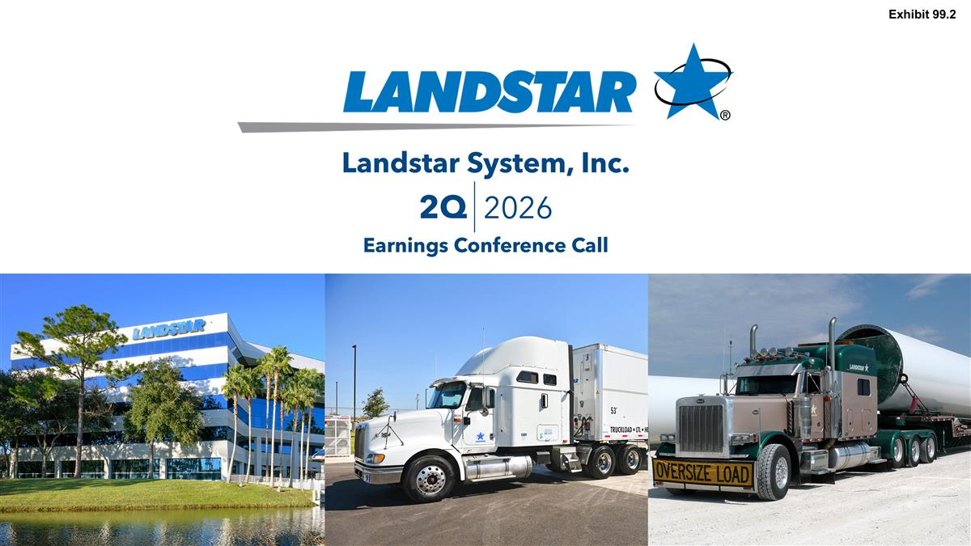
Date Landstar System, Inc. Earnings Conference Call 2Q 2026 Exhibit 99.2

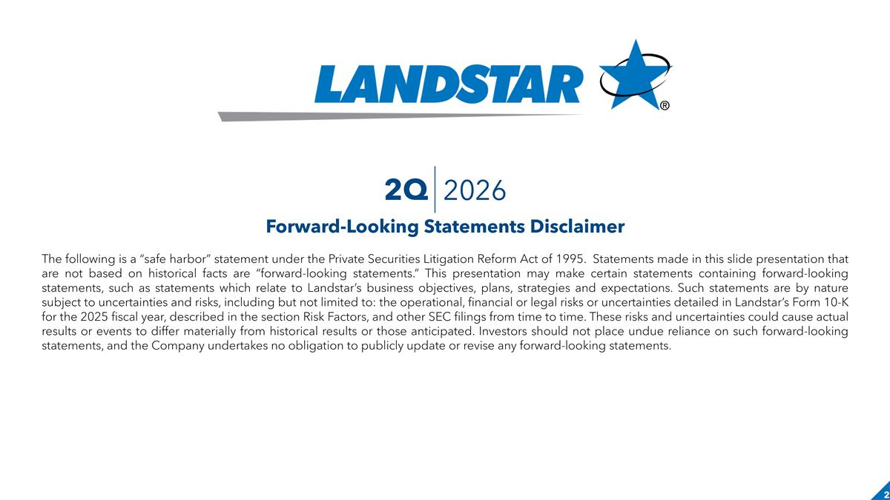
Forward-Looking Statements Disclaimer The following is a “safe harbor” statement under the Private Securities Litigation Reform Act of 1995. Statements made in this slide presentation that are not based on historical facts are “forward-looking statements.” This presentation may make certain statements containing forward-looking statements, such as statements which relate to Landstar’s business objectives, plans, strategies and expectations. Such statements are by nature subject to uncertainties and risks, including but not limited to: the operational, financial or legal risks or uncertainties detailed in Landstar’s Form 10-K for the 2025 fiscal year, described in the section Risk Factors, and other SEC filings from time to time. These risks and uncertainties could cause actual results or events to differ materially from historical results or those anticipated. Investors should not place undue reliance on such forward-looking statements, and the Company undertakes no obligation to publicly update or revise any forward-looking statements. 2Q 2026

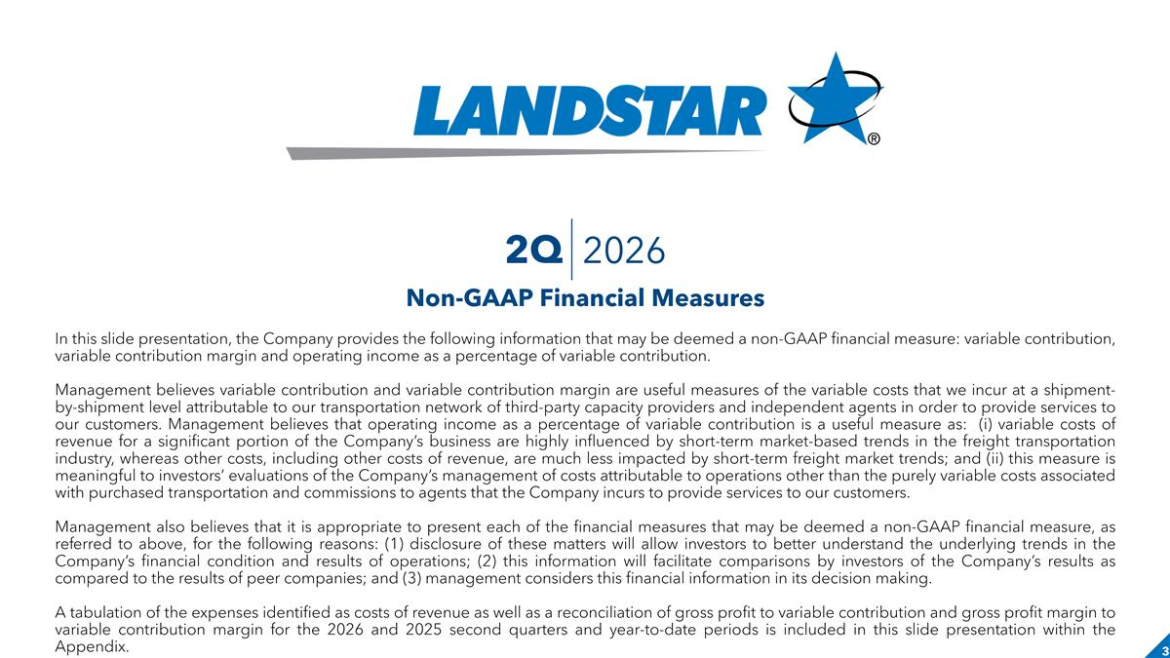
In this slide presentation, the Company provides the following information that may be deemed a non-GAAP financial measure: variable contribution, variable contribution margin and operating income as a percentage of variable contribution. Management believes variable contribution and variable contribution margin are useful measures of the variable costs that we incur at a shipment-by-shipment level attributable to our transportation network of third-party capacity providers and independent agents in order to provide services to our customers. Management believes that operating income as a percentage of variable contribution is a useful measure as: (i) variable costs of revenue for a significant portion of the Company’s business are highly influenced by short-term market-based trends in the freight transportation industry, whereas other costs, including other costs of revenue, are much less impacted by short-term freight market trends; and (ii) this measure is meaningful to investors’ evaluations of the Company’s management of costs attributable to operations other than the purely variable costs associated with purchased transportation and commissions to agents that the Company incurs to provide services to our customers. Management also believes that it is appropriate to present each of the financial measures that may be deemed a non-GAAP financial measure, as referred to above, for the following reasons: (1) disclosure of these matters will allow investors to better understand the underlying trends in the Company’s financial condition and results of operations; (2) this information will facilitate comparisons by investors of the Company’s results as compared to the results of peer companies; and (3) management considers this financial information in its decision making. A tabulation of the expenses identified as costs of revenue as well as a reconciliation of gross profit to variable contribution and gross profit margin to variable contribution margin for the 2026 and 2025 second quarters and year-to-date periods is included in this slide presentation within the Appendix. Non-GAAP Financial Measures 2Q 2026

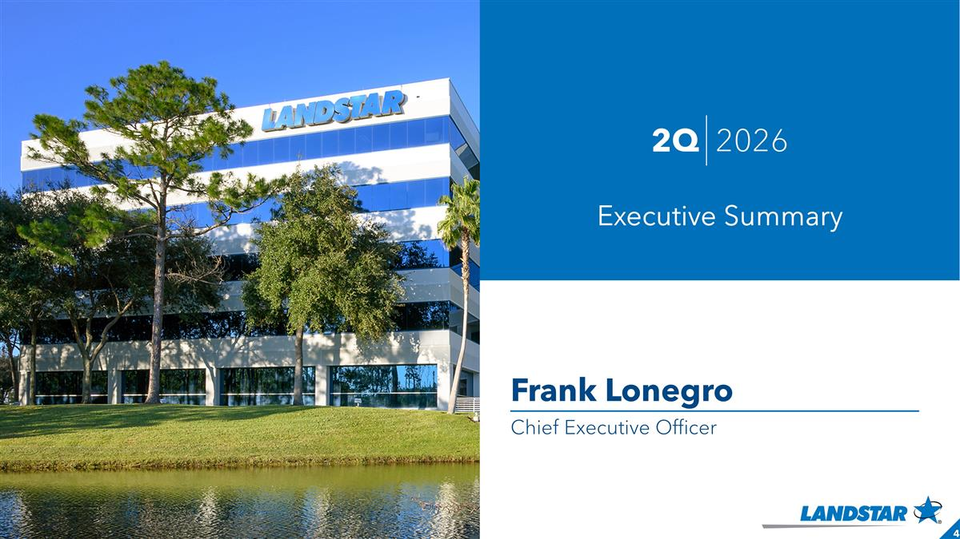
Frank Lonegro Chief Executive Officer 2Q 2026 Executive Summary

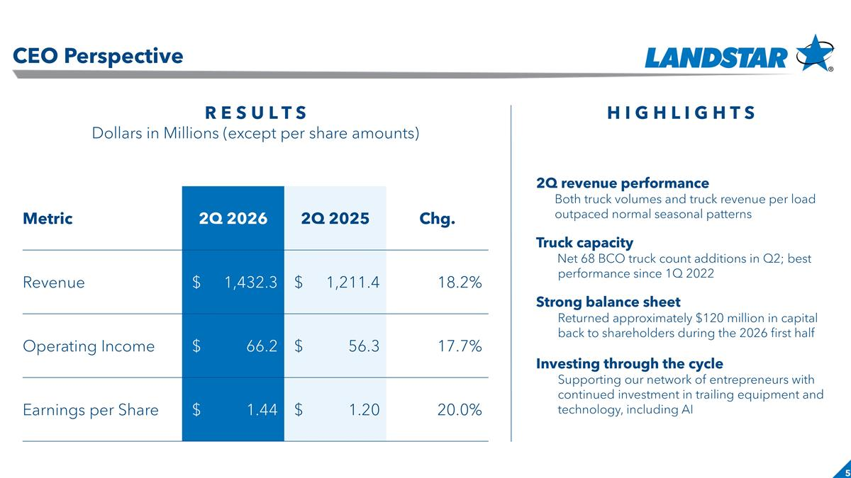
Slide header CEO Perspective R E S U L T S Dollars in Millions (except per share amounts) H I G H L I G H T S 2Q revenue performance Both truck volumes and truck revenue per load outpaced normal seasonal patterns Truck capacity Net 68 BCO truck count additions in Q2; best performance since 1Q 2022 Strong balance sheet Returned approximately $120 million in capital back to shareholders during the 2026 first half Investing through the cycle Supporting our network of entrepreneurs with continued investment in trailing equipment and technology, including AI Metric 2Q 2026 2Q 2025 Chg. Revenue $ 1,432.3 $ 1,211.4 18.2% Operating Income $ 66.2 $ 56.3 17.7% Earnings per Share $ 1.44 $ 1.20 20.0%

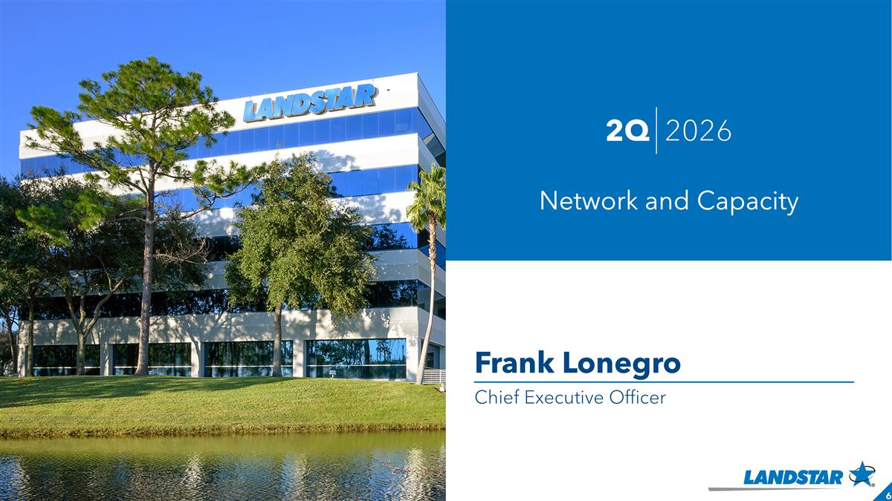
Frank Lonegro Chief Executive Officer 2Q 2026 Network and Capacity

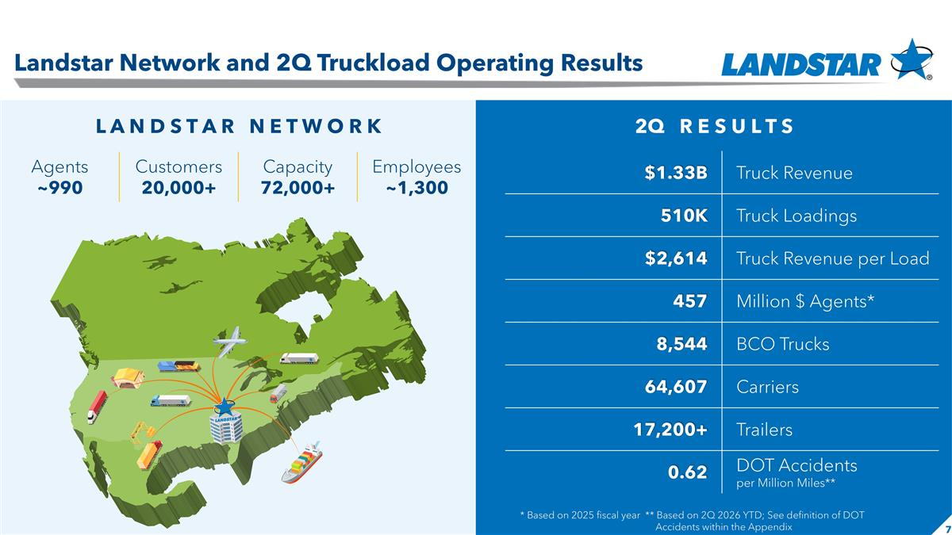
Slide header $1.33B Truck Revenue 510K Truck Loadings $2,614 Truck Revenue per Load 457 Million $ Agents* 8,544 BCO Trucks 64,607 Carriers 17,200+ Trailers 0.62 DOT Accidents per Million Miles** * Based on 2025 fiscal year ** Based on 2Q 2026 YTD; See definition of DOT Accidents within the Appendix 2Q R E S U L T S L A N D S T A R N E T W O R K Agents ~990 Customers 20,000+ Capacity 72,000+ Employees ~1,300 Landstar Network and 2Q Truckload Operating Results

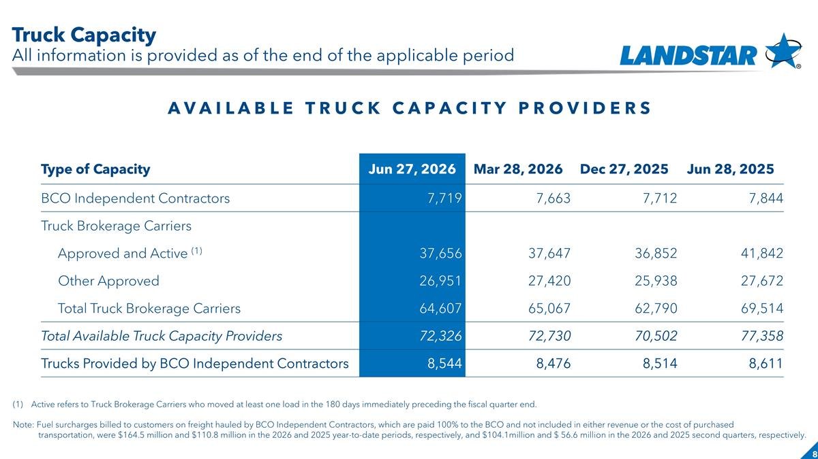
Slide header Active refers to Truck Brokerage Carriers who moved at least one load in the 180 days immediately preceding the fiscal quarter end. Note: Fuel surcharges billed to customers on freight hauled by BCO Independent Contractors, which are paid 100% to the BCO and not included in either revenue or the cost of purchased transportation, were $164.5 million and $110.8 million in the 2026 and 2025 year-to-date periods, respectively, and $104.1million and $ 56.6 million in the 2026 and 2025 second quarters, respectively. A V A I L A B L E T R U C K C A P A C I T Y P R O V I D E R S Type of Capacity Jun 27, 2026 Mar 28, 2026 Dec 27, 2025 Jun 28, 2025 BCO Independent Contractors 7,719 7,663 7,712 7,844 Truck Brokerage Carriers Approved and Active (1) 37,656 37,647 36,852 41,842 Other Approved 26,951 27,420 25,938 27,672 Total Truck Brokerage Carriers 64,607 65,067 62,790 69,514 Total Available Truck Capacity Providers 72,326 72,730 70,502 77,358 Trucks Provided by BCO Independent Contractors 8,544 8,476 8,514 8,611 Truck Capacity All information is provided as of the end of the applicable period

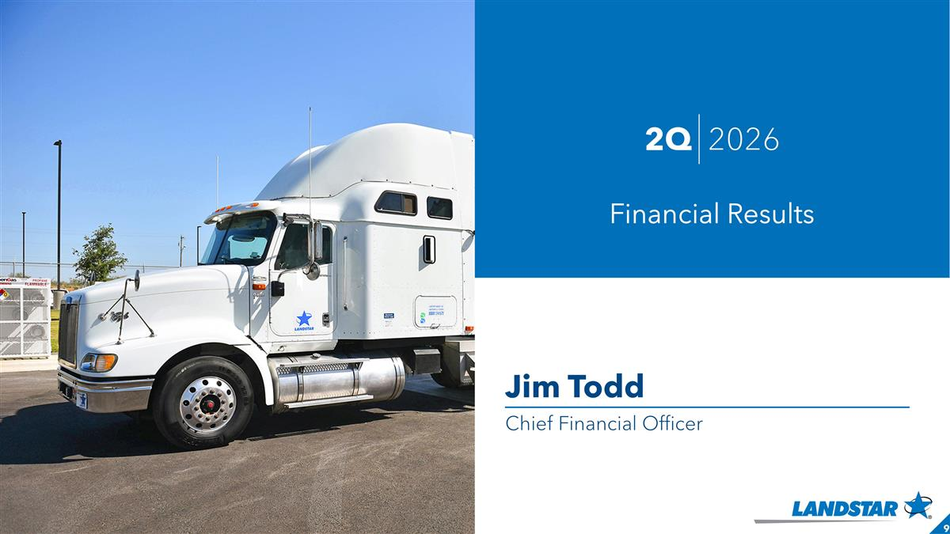
Jim Todd Chief Financial Officer 2Q 2026 Financial Results

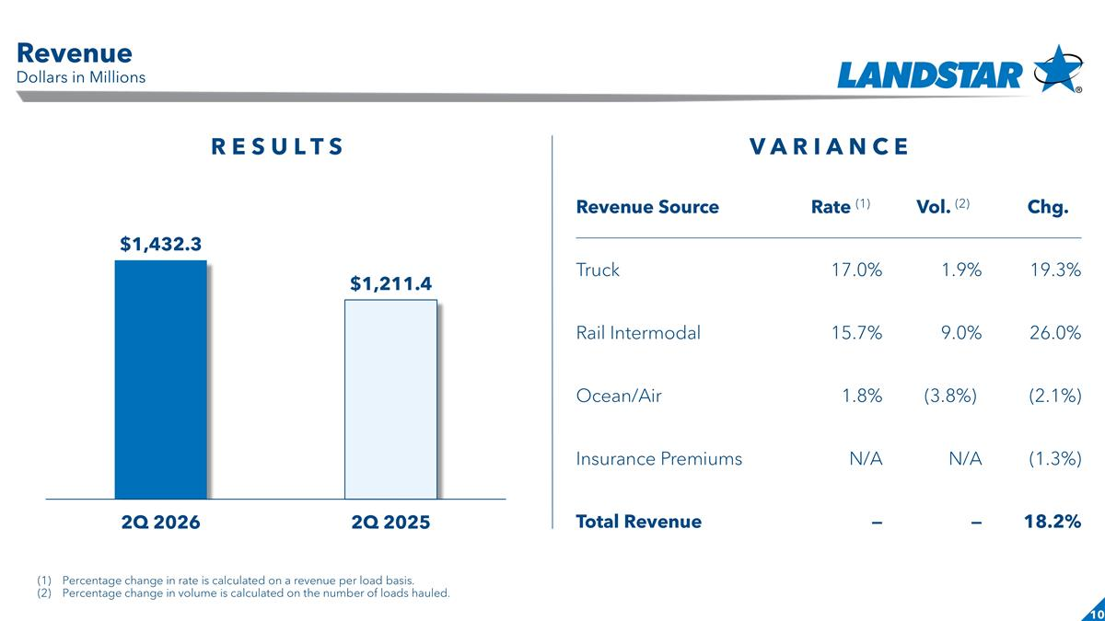
Slide header Revenue Source Rate (1) Vol. (2) Chg. Truck 17.0% 1.9% 19.3% Rail Intermodal 15.7% 9.0% 26.0% Ocean/Air 1.8% (3.8%)) (2.1%) Insurance Premiums N/A N/A (1.3%) Total Revenue — — 18.2% R E S U L T S V A R I A N C E Percentage change in rate is calculated on a revenue per load basis. Percentage change in volume is calculated on the number of loads hauled. Revenue Dollars in Millions

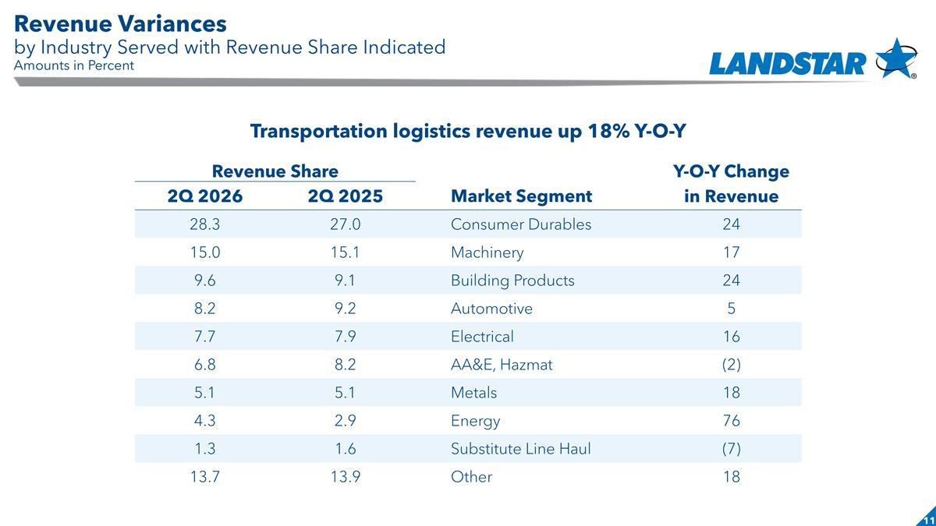
Slide header Revenue Share Y-O-Y Change 2Q 2026 2Q 2025 Market Segment in Revenue 28.3 27.0 Consumer Durables 24 15.0 15.1 Machinery 17 9.6 9.1 Building Products 24 8.2 9.2 Automotive 5 7.7 7.9 Electrical 16 6.8 8.2 AA&E, Hazmat (2) 5.1 5.1 Metals 18 4.3 2.9 Energy 76 1.3 1.6 Substitute Line Haul (7) 13.7 13.9 Other 18 Transportation logistics revenue up 18% Y-O-Y Revenue Variances by Industry Served with Revenue Share Indicated Amounts in Percent

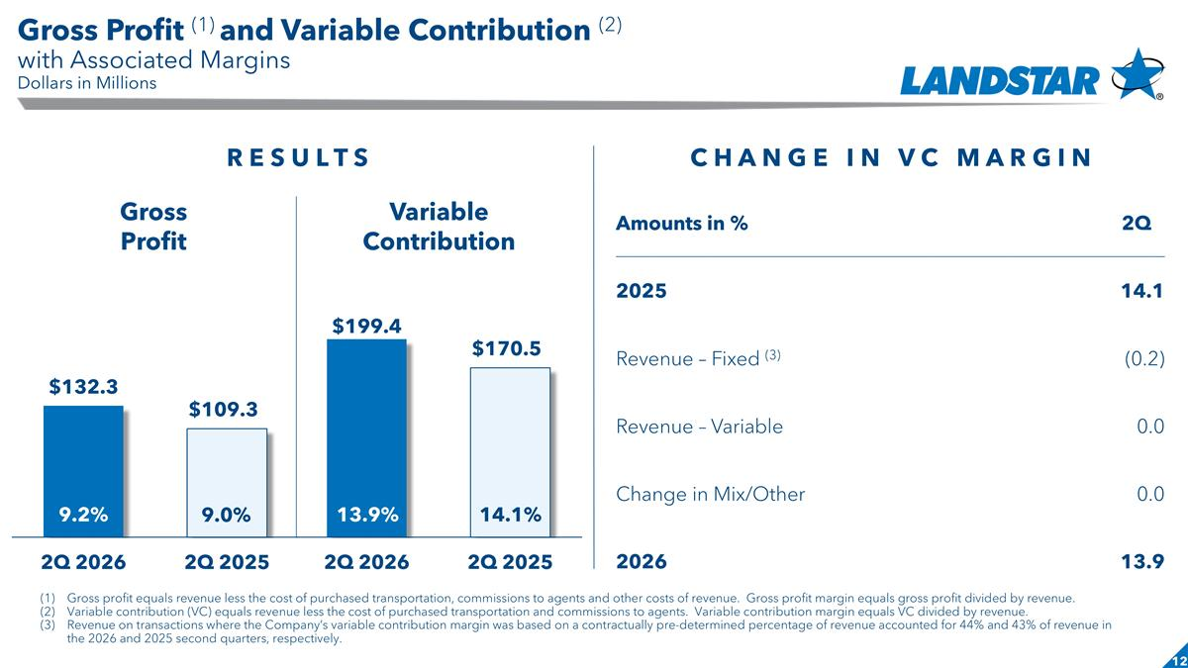
Slide header Gross Profit Variable Contribution Amounts in % 2Q 2025 14.1 Revenue – Fixed (3) (0.2) Revenue – Variable 0.0 Change in Mix/Other 0.0 2026 13.9 C H A N G E I N V C M A R G I N Gross profit equals revenue less the cost of purchased transportation, commissions to agents and other costs of revenue. Gross profit margin equals gross profit divided by revenue. Variable contribution (VC) equals revenue less the cost of purchased transportation and commissions to agents. Variable contribution margin equals VC divided by revenue. Revenue on transactions where the Company’s variable contribution margin was based on a contractually pre-determined percentage of revenue accounted for 44% and 43% of revenue in the 2026 and 2025 second quarters, respectively. R E S U L T S 9.2% 9.0% 13.9% 14.1% Gross Profit (1) and Variable Contribution (2) with Associated Margins Dollars in Millions

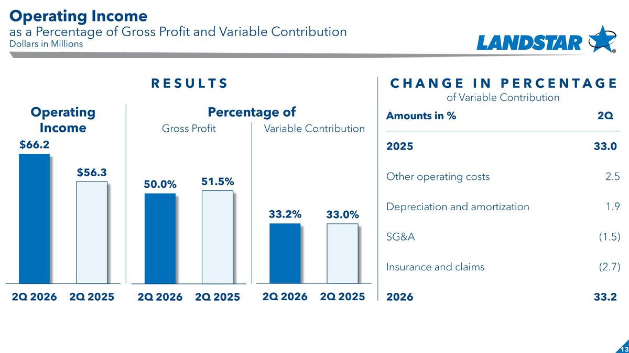
Slide header Operating Income Percentage of Gross Profit Variable Contribution C H A N G E I N P E R C E N T A G E of Variable Contribution R E S U L T S Amounts in % 2Q 2025 33.0) Other operating costs 2.5 Depreciation and amortization 1.9 SG&A (1.5) Insurance and claims (2.7) 2026 33.2) Operating Income as a Percentage of Gross Profit and Variable Contribution Dollars in Millions

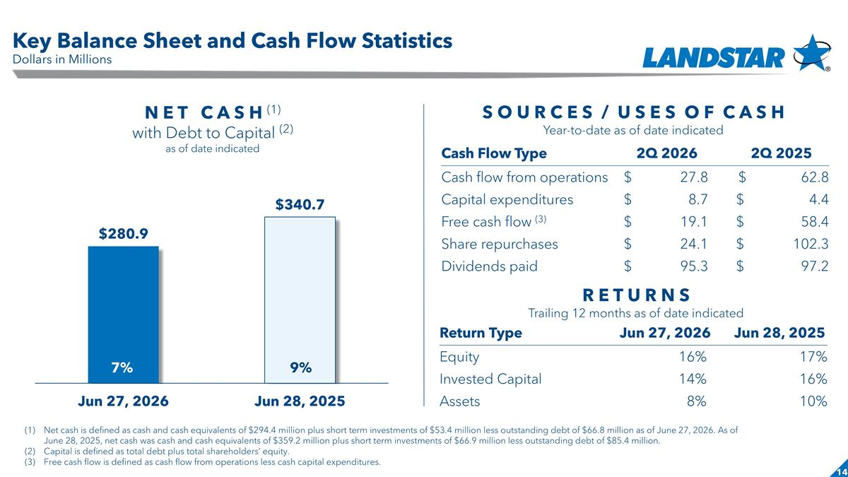
Slide header Return Type Jun 27, 2026 Jun 28, 2025 Equity 16% 17% Invested Capital 14% 16% Assets 8% 10% N E T C A S H (1) with Debt to Capital (2) as of date indicated S O U R C E S / U S E S O F C A S H Year-to-date as of date indicated Cash Flow Type 2Q 2026 2Q 2025 Cash flow from operations $ 27.8 $ 62.8 Capital expenditures $ 8.7 $ 4.4 Free cash flow (3) $ 19.1 $ 58.4 Share repurchases $ 24.1 $ 102.3 Dividends paid $ 95.3 $ 97.2 R E T U R N S Trailing 12 months as of date indicated Net cash is defined as cash and cash equivalents of $294.4 million plus short term investments of $53.4 million less outstanding debt of $66.8 million as of June 27, 2026. As of June 28, 2025, net cash was cash and cash equivalents of $359.2 million plus short term investments of $66.9 million less outstanding debt of $85.4 million. Capital is defined as total debt plus total shareholders’ equity. Free cash flow is defined as cash flow from operations less cash capital expenditures. 7% 9% Key Balance Sheet and Cash Flow Statistics Dollars in Millions

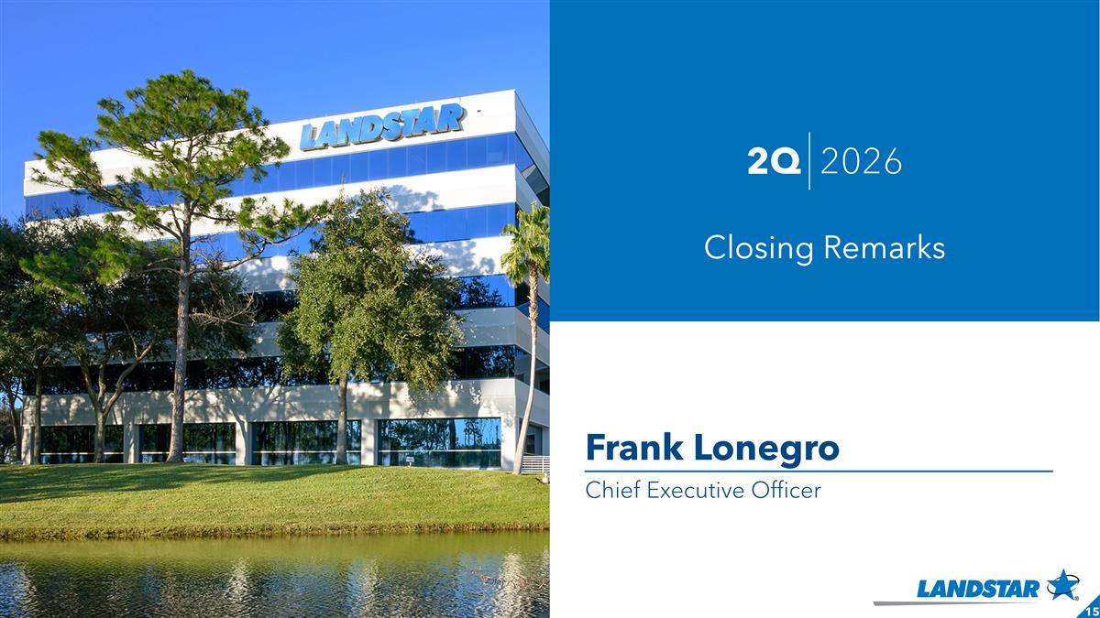
Frank Lonegro Chief Executive Officer 2Q 2026 Closing Remarks

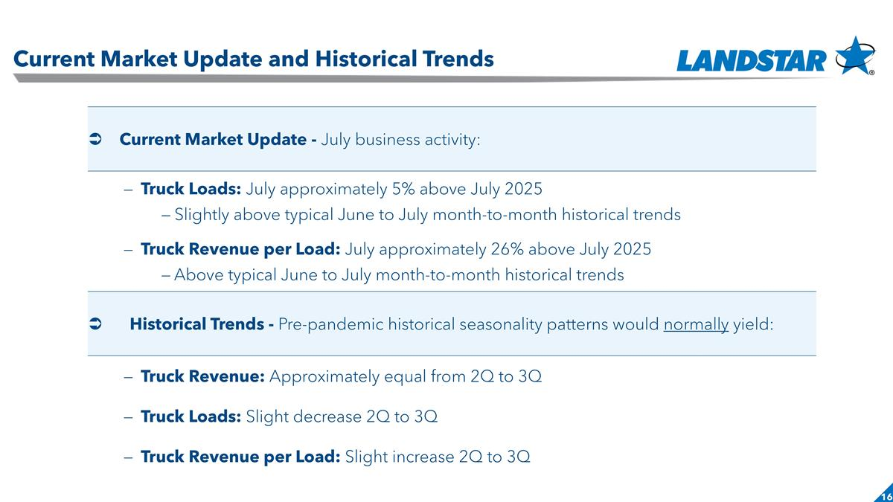
Slide header Current Market Update and Historical Trends Ü Current Market Update - July business activity: – Truck Loads: July approximately 5% above July 2025 – Slightly above typical June to July month-to-month historical trends – Truck Revenue per Load: July approximately 26% above July 2025 – Above typical June to July month-to-month historical trends Historical Trends - Pre-pandemic historical seasonality patterns would normally yield: – Truck Revenue: Approximately equal from 2Q to 3Q – Truck Loads: Slight decrease 2Q to 3Q – Truck Revenue per Load: Slight increase 2Q to 3Q

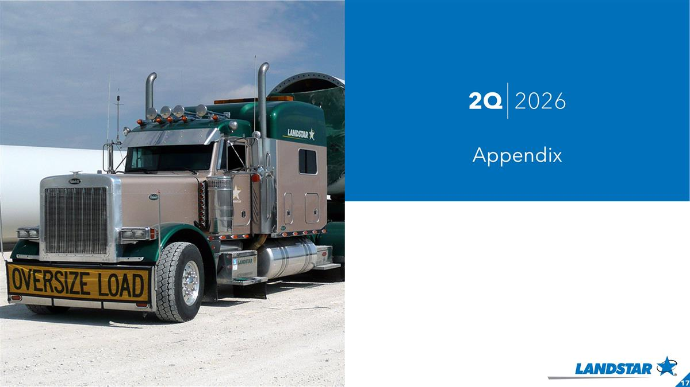
2Q 2026 Appendix

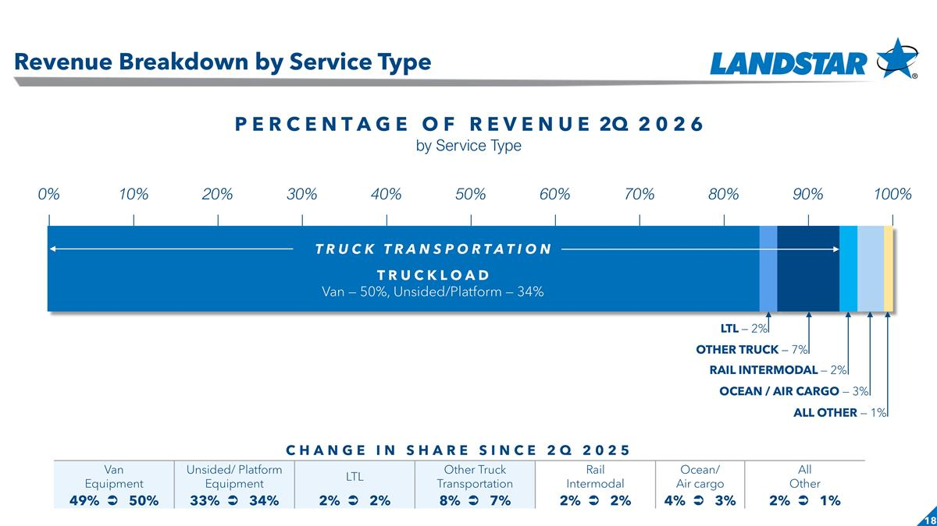
Slide header Revenue Breakdown by Service Type P E R C E N T A G E O F R E V E N U E 2Q 2 0 2 6 by Service Type LTL — 2% T R U C K L O A D Van — 50%, Unsided/Platform — 34% OTHER TRUCK — 7% T R U C K T R A N S P O R T A T I O N RAIL INTERMODAL — 2% OCEAN / AIR CARGO — 3% CHANGE IN SHARE SINCE 2Q 2025 Van Equipment Unsided/ Platform Equipment LTL Other Truck Transportation Rail Intermodal Ocean/ Air cargo All Other 49% Ü 50% 33% Ü 34% 2% Ü 2% 8% Ü 7% 2% Ü 2% 4% Ü 3% 2% Ü 1% ALL OTHER — 1%

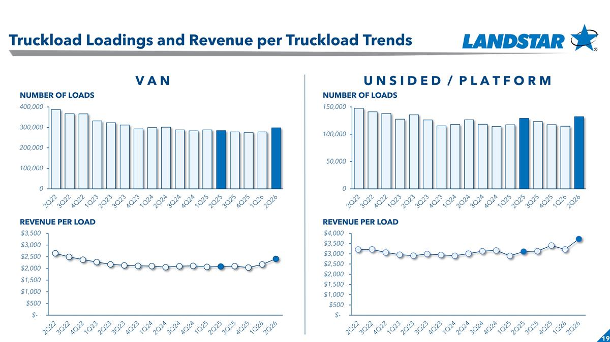
Slide header Truckload Loadings and Revenue per Truckload Trends U N S I D E D / P L A T F O R M V A N NUMBER OF LOADS REVENUE PER LOAD NUMBER OF LOADS REVENUE PER LOAD

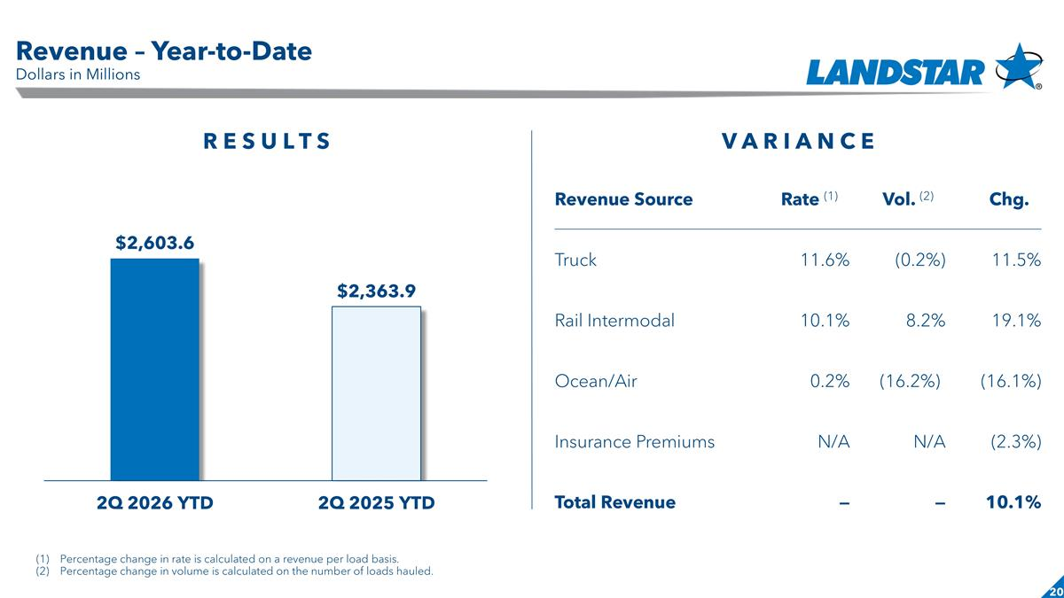
Slide header Revenue – Year-to-Date Dollars in Millions Revenue Source Rate (1) Vol. (2) Chg. Truck 11.6% (0.2%) 11.5% Rail Intermodal 10.1% 8.2% 19.1% Ocean/Air 0.2% (16.2%)) (16.1%) Insurance Premiums N/A N/A (2.3%) Total Revenue — — 10.1% R E S U L T S V A R I A N C E Percentage change in rate is calculated on a revenue per load basis. Percentage change in volume is calculated on the number of loads hauled.

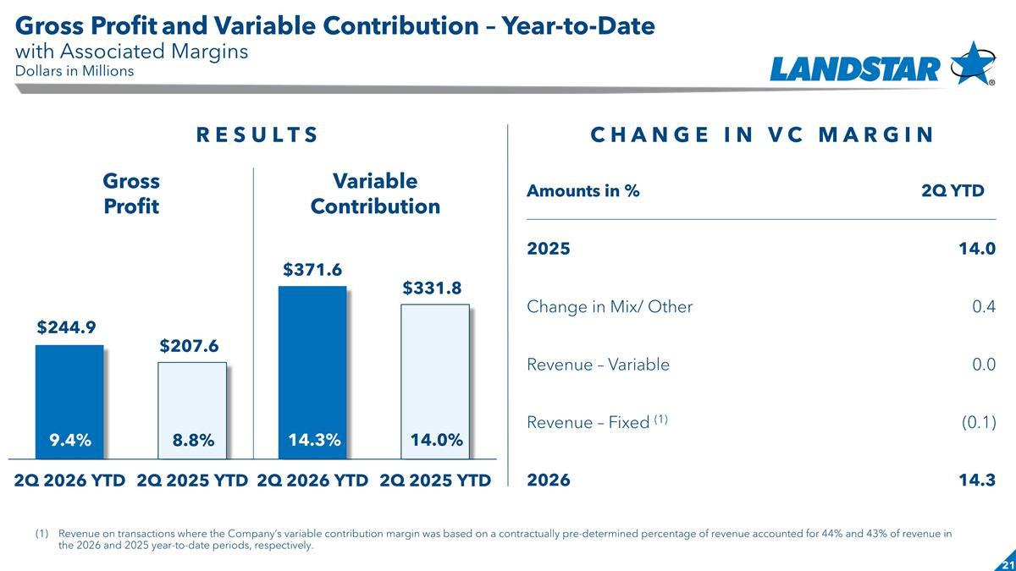
Slide header Gross Profit and Variable Contribution – Year-to-Date with Associated Margins Dollars in Millions Gross Profit Variable Contribution Amounts in % 2Q YTD 2025 14.0 Change in Mix/ Other 0.4 Revenue – Variable 0.0 Revenue – Fixed (1) (0.1) 2026 14.3 C H A N G E I N V C M A R G I N Revenue on transactions where the Company’s variable contribution margin was based on a contractually pre-determined percentage of revenue accounted for 44% and 43% of revenue in the 2026 and 2025 year-to-date periods, respectively. R E S U L T S 9.4% 8.8% 14.3% 14.0%

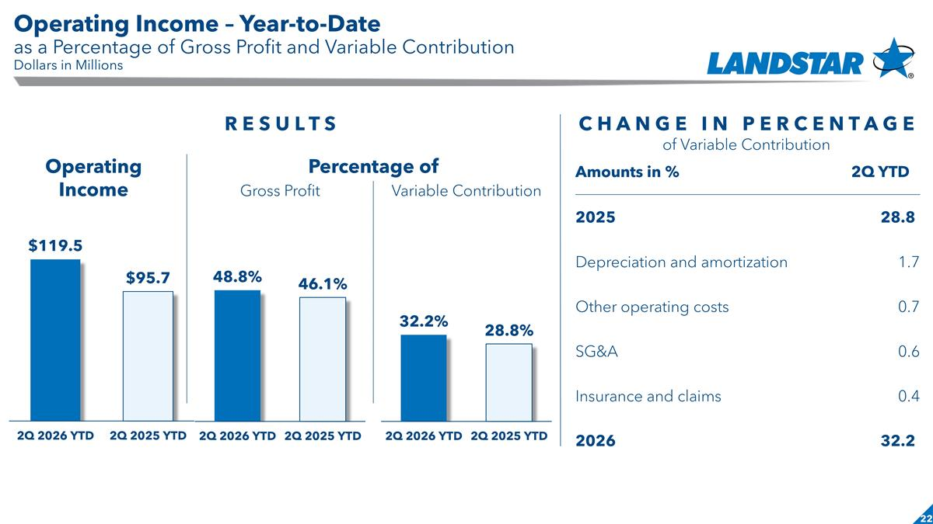
Slide header Operating Income – Year-to-Date as a Percentage of Gross Profit and Variable Contribution Dollars in Millions Operating Income Percentage of Gross Profit Variable Contribution C H A N G E I N P E R C E N T A G E of Variable Contribution R E S U L T S Amounts in % 2Q YTD 2025 28.8) Depreciation and amortization 1.7 Other operating costs 0.7 SG&A 0.6 Insurance and claims 0.4 2026 32.2)

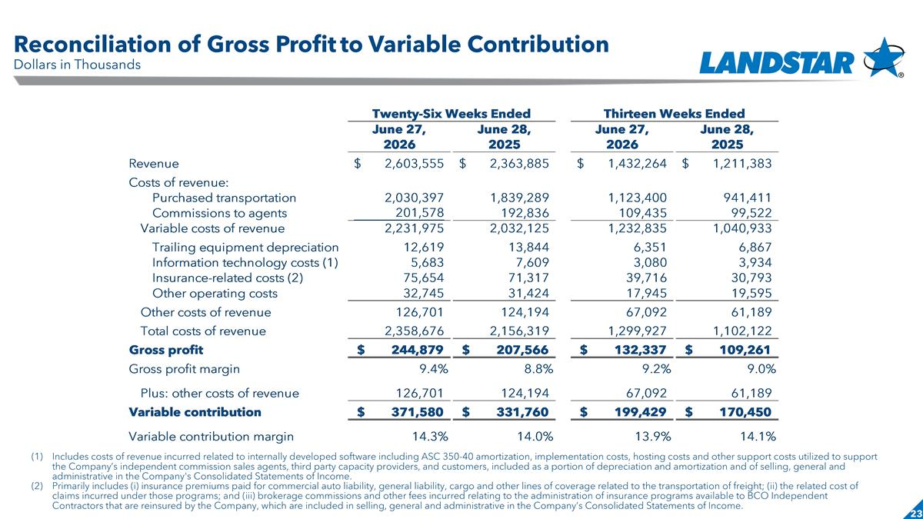
Slide header Reconciliation of Gross Profit to Variable Contribution Dollars in Thousands Includes costs of revenue incurred related to internally developed software including ASC 350-40 amortization, implementation costs, hosting costs and other support costs utilized to support the Company’s independent commission sales agents, third party capacity providers, and customers, included as a portion of depreciation and amortization and of selling, general and administrative in the Company's Consolidated Statements of Income. Primarily includes (i) insurance premiums paid for commercial auto liability, general liability, cargo and other lines of coverage related to the transportation of freight; (ii) the related cost of claims incurred under those programs; and (iii) brokerage commissions and other fees incurred relating to the administration of insurance programs available to BCO Independent Contractors that are reinsured by the Company, which are included in selling, general and administrative in the Company’s Consolidated Statements of Income. 2010 2011 2009 % Proj % Plan % External Revenue #REF! #REF! #REF! Purchased Transportation 0 #REF! 0 #REF! #REF! #REF! Commissions to Agents 0 #REF! 0 #REF! #REF! #REF! Net Revenue #REF! #REF! #REF! #REF! #REF! #REF! Investment Income 0 #REF! #VALUE! #VALUE! #REF! 1.1% Other Operating Costs #REF! #REF! #REF! #REF! #REF! #REF! Insurance Expense #REF! #REF! #REF! #REF! #REF! #REF! SG&A #REF! #REF! #REF! #REF! #REF! #REF! Depreciation and Amortization #REF! #REF! #REF! #REF! #REF! #REF! Operating Income #REF! #REF! #REF! #REF! #REF! #REF! Interest and Debt Expense #REF! #REF! #REF! Income Before Income Taxes #REF! #REF! #REF! Income Taxes #REF! #REF! #REF! Net Income #REF! #REF! #REF! Diluted Earnings per Share Shares Diluted Earnings per Share % of 2013 % of 2013 % of Twenty-Six Weeks Ended Thirteen Weeks Ended June 27, June 28, June 27, June 28, 2026 2025 2026 2025 2012 Rev/GP Plan Rev/GP Proj Rev/GP Revenue $2,603,555 $2,363,885 $1,432,264 $1,211,383 External Revenue #REF! #REF! #REF! Costs of revenue: Purchased Transportation #REF! #REF! #REF! #REF! #REF! #REF! Purchased transportation 2,030,397 1,839,289 1,123,400 ,941,411 Commissions to agents ,201,578 ,192,836 ,109,435 99,522 Variable costs of revenue 2,231,975 2,032,125 1,232,835 1,040,933 Interest and Debt Expense #REF! #REF! #REF! Income Before Income Taxes #REF! #REF! #REF! Trailing equipment depreciation 12,619 13,844 6,351 6,867 Information technology costs (1) 5,683 7,609 3,080 3,934 Insurance-related costs (2) 75,654 71,317 39,716 30,793 Income Taxes #REF! #REF! #REF! Other operating costs 32,745 31,424 17,945 19,595 Other costs of revenue ,126,701 ,124,194 67,092 61,189 Total costs of revenue 2,358,676 2,156,319 1,299,927 1,102,122 Gross profit $,244,879 $,207,566 $,132,337 $,109,261 Gross profit margin 9.4% 8.8% 9.2% 9.2% Plus: other costs of revenue ,126,701 ,124,194 67,092 61,189 Variable contribution $,371,580 $,331,760 $,199,429 $,170,450 Variable contribution margin 0.14299999999999999 0.14034523676067151 0.13900000000000001 0.14070694404659798 (1) Includes costs of revenue incurred related to internally developed software including ASC 350-40 amortization, implementation costs, hosting costs and other support costs utilized to support the Company’s independent commission sales agents, third party capacity providers, and customers, included as a portion of depreciation and amortization and of selling, general and administrative in the Company's Consolidated Statements of Income. (2) Primarily includes (i) insurance premiums paid for commercial auto liability, general liability, cargo and other lines of coverage related to the transportation of freight; (ii) the related cost of claims incurred under those programs; and (iii) brokerage commissions and other fees incurred relating to the administration of insurance programs available to BCO Independent Contractors that are reinsured by the Company, which are included in selling, general and administrative in the Company’s Consolidated Statements of Income. 2010 2011 2009 % Proj % Plan % External Revenue #REF! #REF! #REF! Purchased Transportation 0 #REF! 0 #REF! #REF! #REF! Commissions to Agents 0 #REF! 0 #REF! #REF! #REF! Net Revenue #REF! #REF! #REF! #REF! #REF! #REF! Investment Income 0 #REF! #VALUE! #VALUE! #REF! 1.1% Other Operating Costs #REF! #REF! #REF! #REF! #REF! #REF! Insurance Expense #REF! #REF! #REF! #REF! #REF! #REF! SG&A #REF! #REF! #REF! #REF! #REF! #REF! Depreciation and Amortization #REF! #REF! #REF! #REF! #REF! #REF! Operating Income #REF! #REF! #REF! #REF! #REF! #REF! Interest and Debt Expense #REF! #REF! #REF! Income Before Income Taxes #REF! #REF! #REF! Income Taxes #REF! #REF! #REF! Net Income #REF! #REF! #REF! Diluted Earnings per Share Shares Diluted Earnings per Share % of 2013 % of 2013 % of Twenty-Six Weeks Ended Thirteen Weeks Ended June 27, June 28, June 27, June 28, 2026 2025 2026 2025 2012 Rev/GP Plan Rev/GP Proj Rev/GP Revenue $2,603,555 $2,363,885 $1,432,264 $1,211,383 External Revenue #REF! #REF! #REF! Costs of revenue: Purchased Transportation #REF! #REF! #REF! #REF! #REF! #REF! Purchased transportation 2,030,397 1,839,289 1,123,400 ,941,411 Commissions to agents ,201,578 ,192,836 ,109,435 99,522 Variable costs of revenue 2,231,975 2,032,125 1,232,835 1,040,933 Interest and Debt Expense #REF! #REF! #REF! Income Before Income Taxes #REF! #REF! #REF! Trailing equipment depreciation 12,619 13,844 6,351 6,867 Information technology costs (1) 5,683 7,609 3,080 3,934 Insurance-related costs (2) 75,654 71,317 39,716 30,793 Income Taxes #REF! #REF! #REF! Other operating costs 32,745 31,424 17,945 19,595 Other costs of revenue ,126,701 ,124,194 67,092 61,189 Total costs of revenue 2,358,676 2,156,319 1,299,927 1,102,122 Gross profit $,244,879 $,207,566 $,132,337 $,109,261 Gross profit margin 9.4% 8.8% 9.2% 9.2% Plus: other costs of revenue ,126,701 ,124,194 67,092 61,189 Variable contribution $,371,580 $,331,760 $,199,429 $,170,450 Variable contribution margin 0.14299999999999999 0.14034523676067151 0.13900000000000001 0.14070694404659798 (1) Includes costs of revenue incurred related to internally developed software including ASC 350-40 amortization, implementation costs, hosting costs and other support costs utilized to support the Company’s independent commission sales agents, third party capacity providers, and customers, included as a portion of depreciation and amortization and of selling, general and administrative in the Company's Consolidated Statements of Income. (2) Primarily includes (i) insurance premiums paid for commercial auto liability, general liability, cargo and other lines of coverage related to the transportation of freight; (ii) the related cost of claims incurred under those programs; and (iii) brokerage commissions and other fees incurred relating to the administration of insurance programs available to BCO Independent Contractors that are reinsured by the Company, which are included in selling, general and administrative in the Company’s Consolidated Statements of Income.

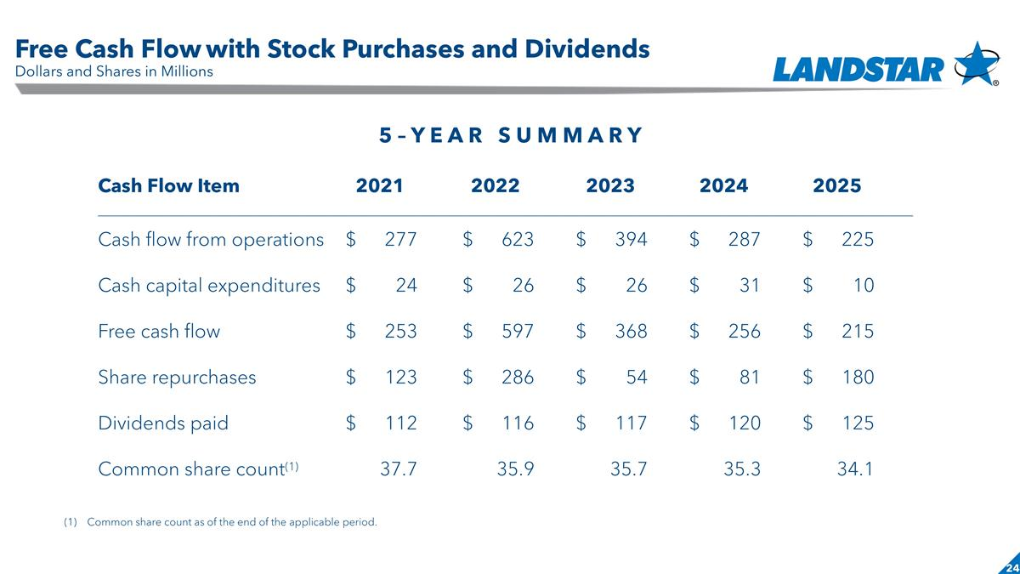
Slide header Free Cash Flow with Stock Purchases and Dividends Dollars and Shares in Millions 5 – Y E A R S U M M A R Y Cash Flow Item 2021 2022 2023 2024 2025 Cash flow from operations $ 277 $ 623 $ 394 $ 287 $ 225 Cash capital expenditures $ 24 $ 26 $ 26 $ 31 $ 10 Free cash flow $ 253 $ 597 $ 368 $ 256 $ 215 Share repurchases $ 123 $ 286 $ 54 $ 81 $ 180 Dividends paid $ 112 $ 116 $ 117 $ 120 $ 125 Common share count(1) 37.7 35.9 35.7 35.3 34.1 Common share count as of the end of the applicable period.

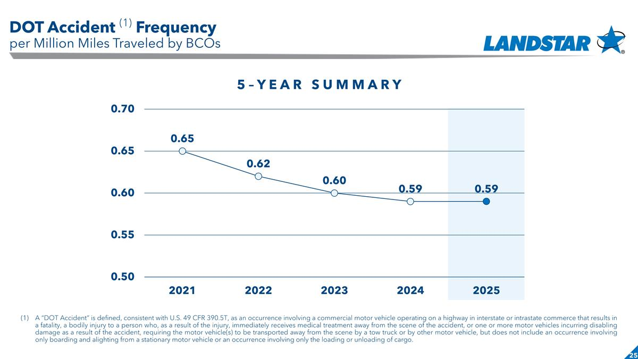
Slide header DOT Accident (1) Frequency per Million Miles Traveled by BCOs 5 – Y E A R S U M M A R Y A “DOT Accident” is defined, consistent with U.S. 49 CFR 390.5T, as an occurrence involving a commercial motor vehicle operating on a highway in interstate or intrastate commerce that results in a fatality, a bodily injury to a person who, as a result of the injury, immediately receives medical treatment away from the scene of the accident, or one or more motor vehicles incurring disabling damage as a result of the accident, requiring the motor vehicle(s) to be transported away from the scene by a tow truck or by other motor vehicle, but does not include an occurrence involving only boarding and alighting from a stationary motor vehicle or an occurrence involving only the loading or unloading of cargo.

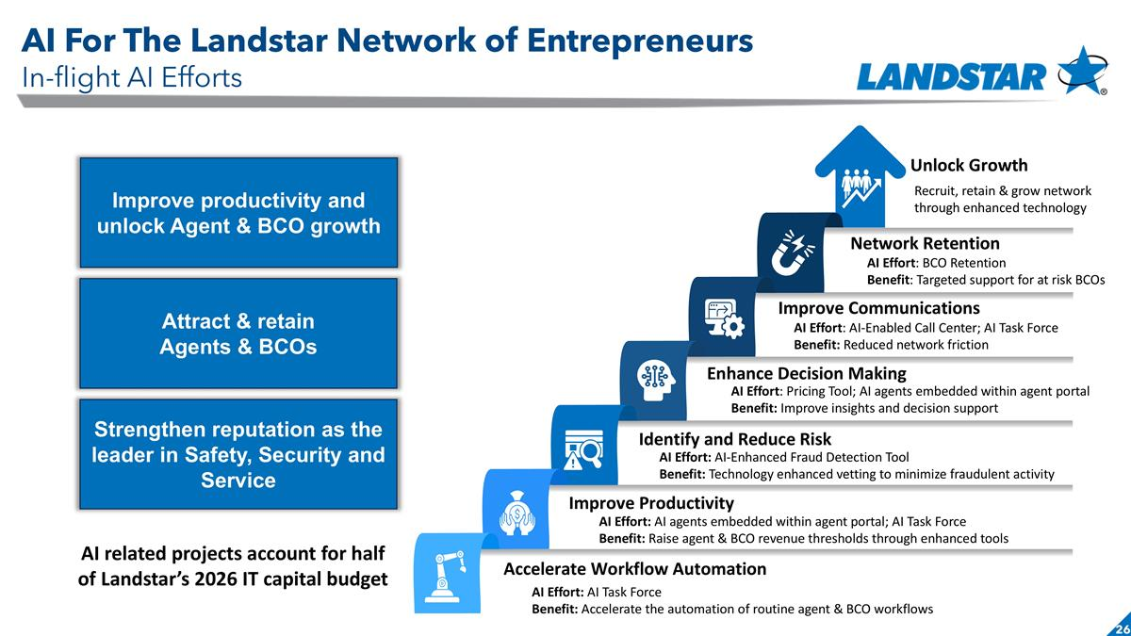
AI Effort: AI Task Force Benefit: Accelerate the automation of routine agent & BCO workflows Unlock Growth Network Retention Improve Communications Enhance Decision Making Identify and Reduce Risk Improve Productivity Accelerate Workflow Automation Recruit, retain & grow network through enhanced technology AI Effort: BCO Retention Benefit: Targeted support for at risk BCOs AI Effort: AI agents embedded within agent portal; AI Task Force Benefit: Raise agent & BCO revenue thresholds through enhanced tools AI Effort: AI-Enhanced Fraud Detection Tool Benefit: Technology enhanced vetting to minimize fraudulent activity AI Effort: Pricing Tool; AI agents embedded within agent portal Benefit: Improve insights and decision support AI Effort: AI-Enabled Call Center; AI Task Force Benefit: Reduced network friction Improve productivity and unlock Agent & BCO growth Attract & retain Agents & BCOs Strengthen reputation as the leader in Safety, Security and Service AI For The Landstar Network of Entrepreneurs In-flight AI Efforts AI related projects account for half of Landstar’s 2026 IT capital budget

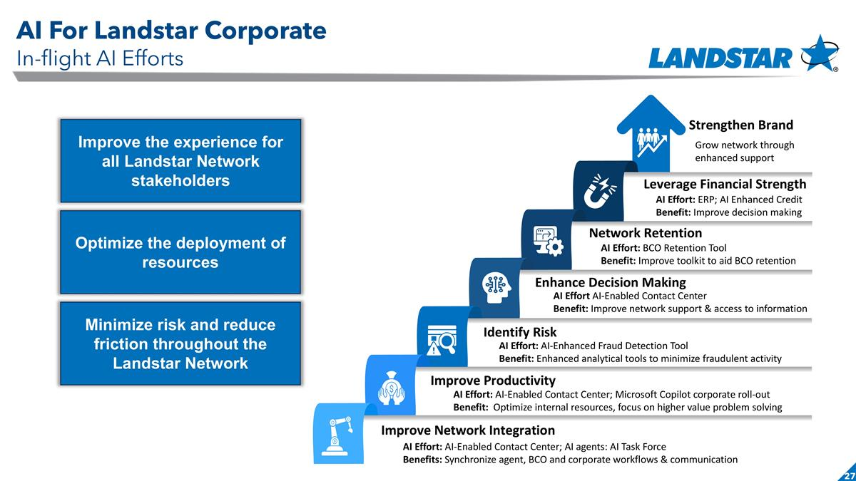
AI Effort: AI-Enabled Contact Center; AI agents: AI Task Force Benefits: Synchronize agent, BCO and corporate workflows & communication Strengthen Brand Leverage Financial Strength Network Retention Enhance Decision Making Identify Risk Improve Productivity Improve Network Integration Grow network through enhanced support AI Effort: ERP; AI Enhanced Credit Benefit: Improve decision making AI Effort: AI-Enabled Contact Center; Microsoft Copilot corporate roll-out Benefit: Optimize internal resources, focus on higher value problem solving AI Effort: AI-Enhanced Fraud Detection Tool Benefit: Enhanced analytical tools to minimize fraudulent activity AI Effort AI-Enabled Contact Center Benefit: Improve network support & access to information AI Effort: BCO Retention Tool Benefit: Improve toolkit to aid BCO retention Improve the experience for all Landstar Network stakeholders Optimize the deployment of resources Minimize risk and reduce friction throughout the Landstar Network AI For Landstar Corporate In-flight AI Efforts

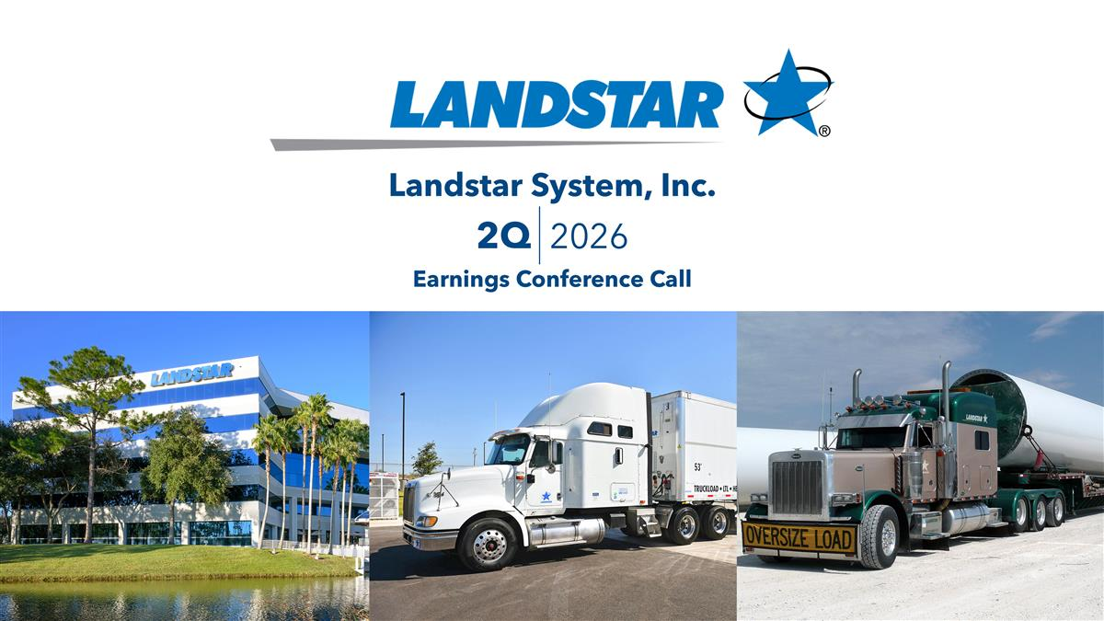
Date Landstar System, Inc. Earnings Conference Call 2Q 2026

